**Vaibhav Khullar**

**vaibhavkhullar55@gmail.com**

**“Be a Devops Pro”**

**Assignment 1**

**Assignment 1:**

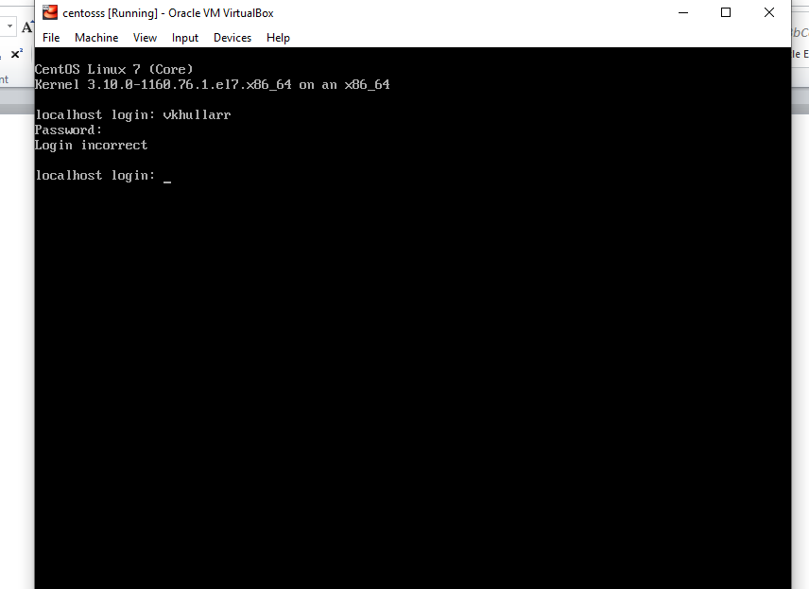

When we enter incorrect login id, OS throws “Login incorrect” error message.

**Assignment 2:**

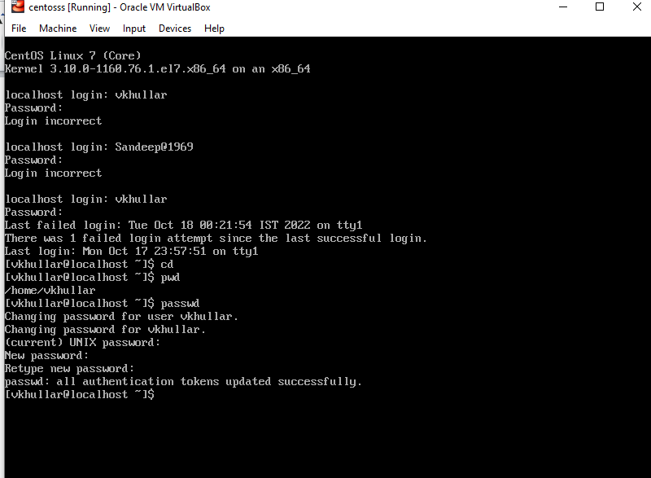

I am able to change password if I type “IneuROn#42” as new password.

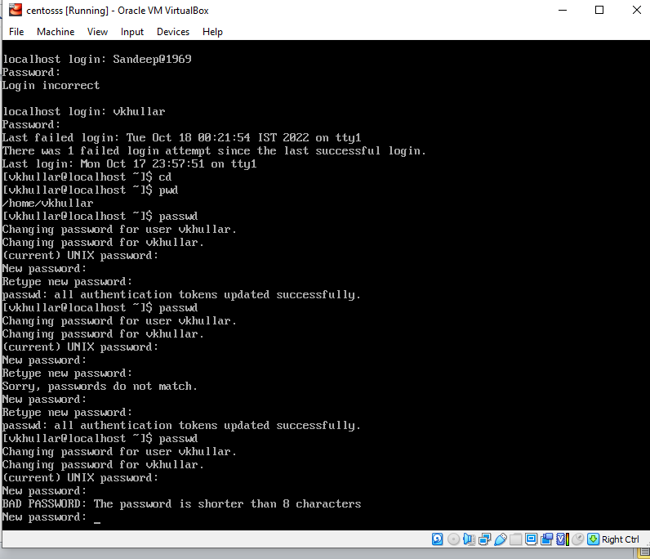

When I enter “abcd” or “1234”, “The password is shorter than 8 characters” error is thrown.

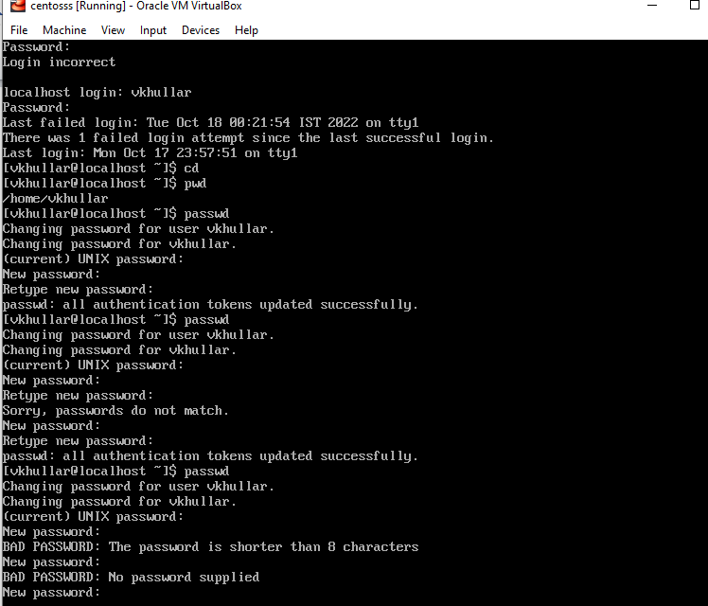

When I do not enter anything and then click on enter,”No password supplied” error is thrown.

**Assignment 3:**

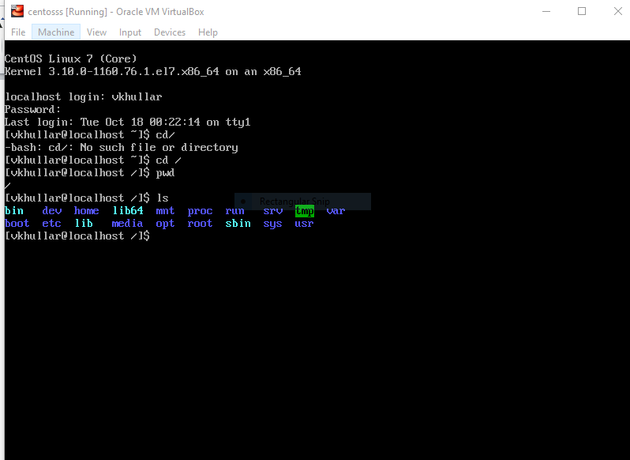

When we enter cd /, directory gets changed to root directory.

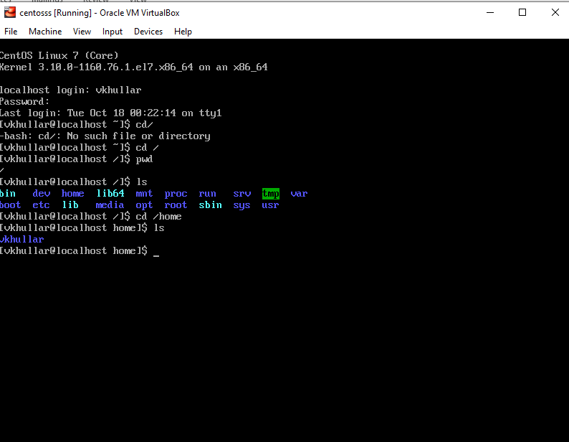

When we enter cd /home, we are navigated to home directory. Home directory is used to store user’s all personal information, files and user information.

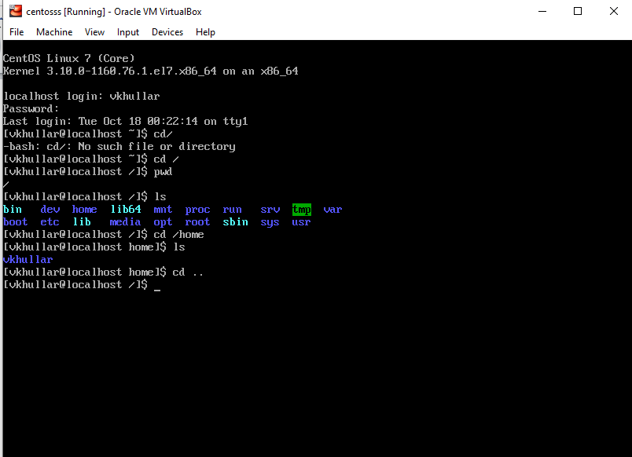

When we enter cd .., it takes us one step directory backwards.

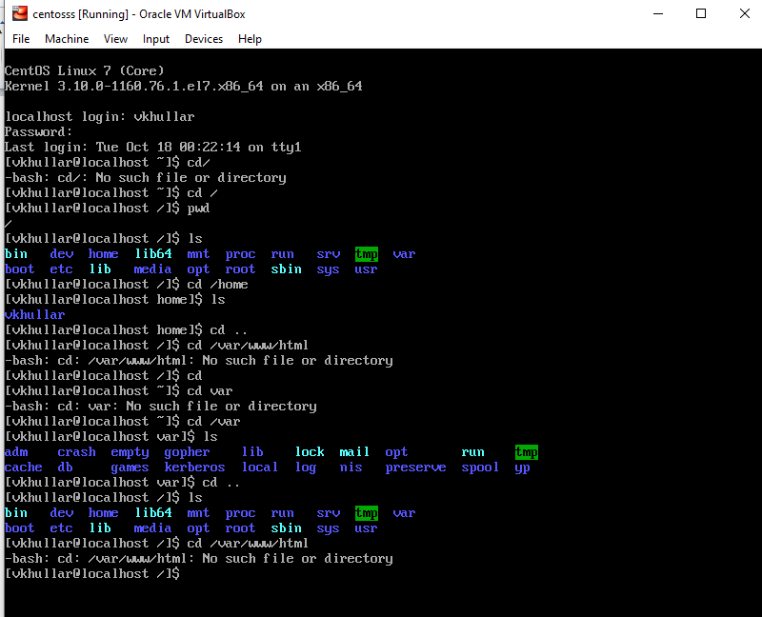

When we enter cd /var/www/html, error will come as there is no such directory in /var.

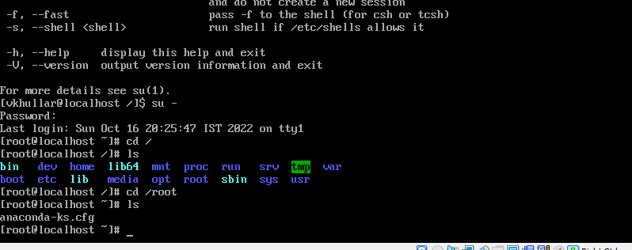

“anaconda-ks.cfg” comes when I login as root user and enter the command “cd /root”

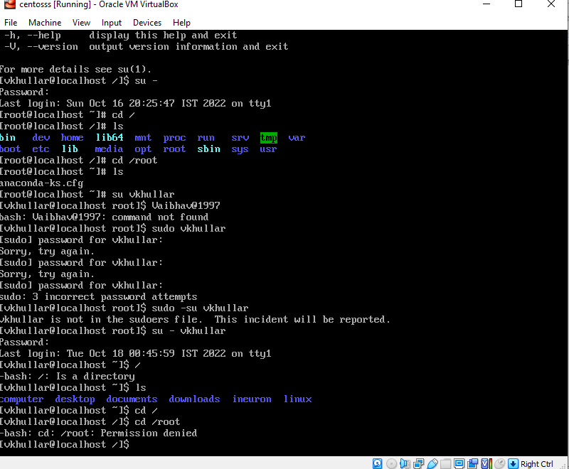

For normal user login, Permission denied error pops up when we enter “cd /root” command in CP.

**Assignment 4:**

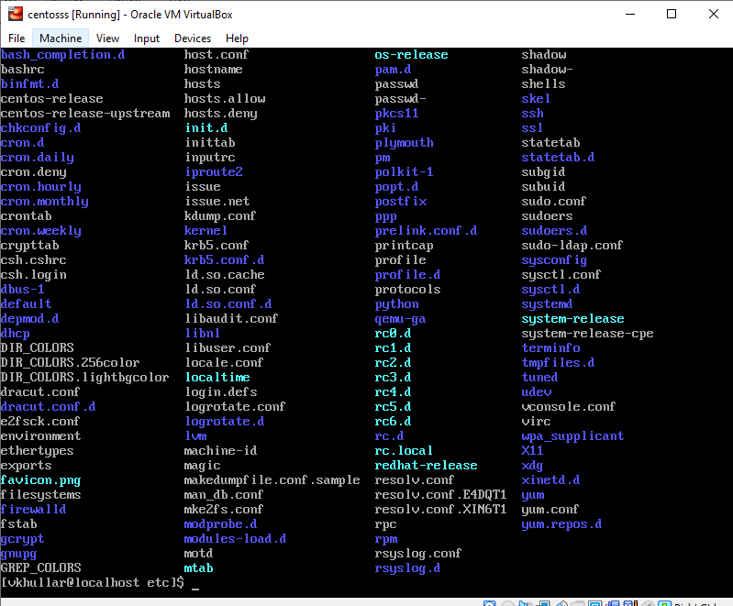

When we enter cd /etc and then click on enter ls command, it lists down all linux system’s configuration files.

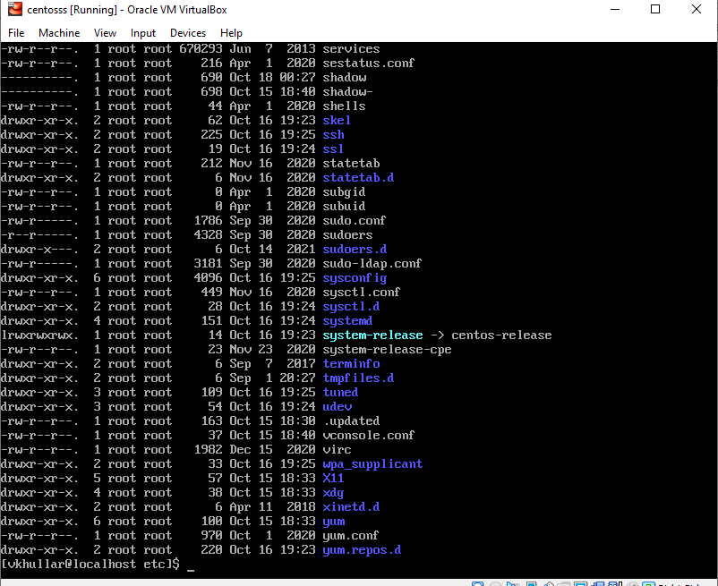

When we enter ls –al and click on enter key, it lists down files and directories with their respective permissions.

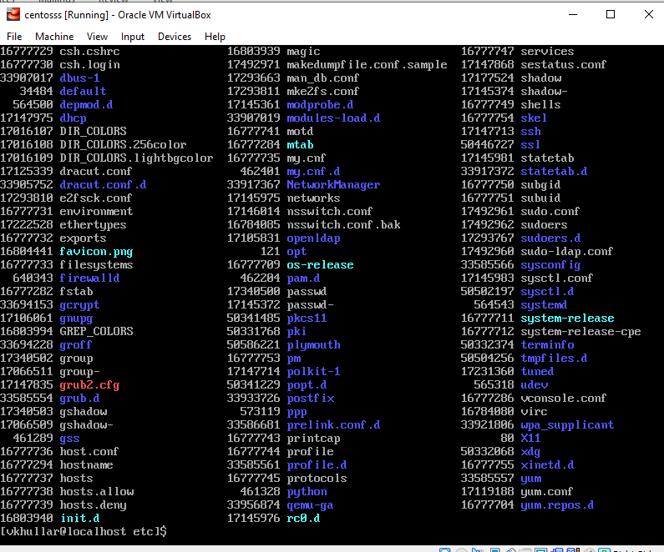

When we enter ls- I and click on enter key, it displays index number of the respective files.

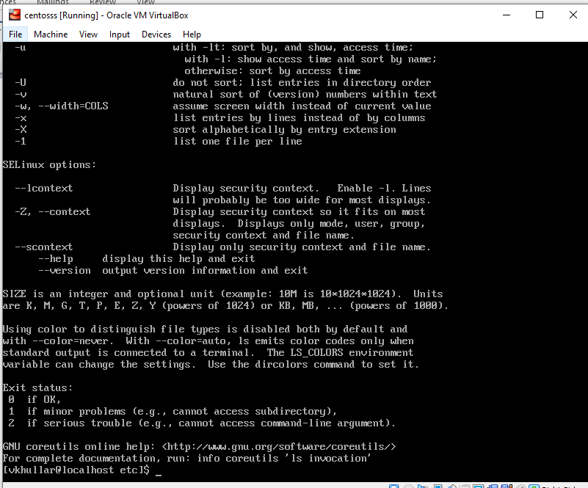

When we enter ls –help, help page gets open.

**Assignment 5:**

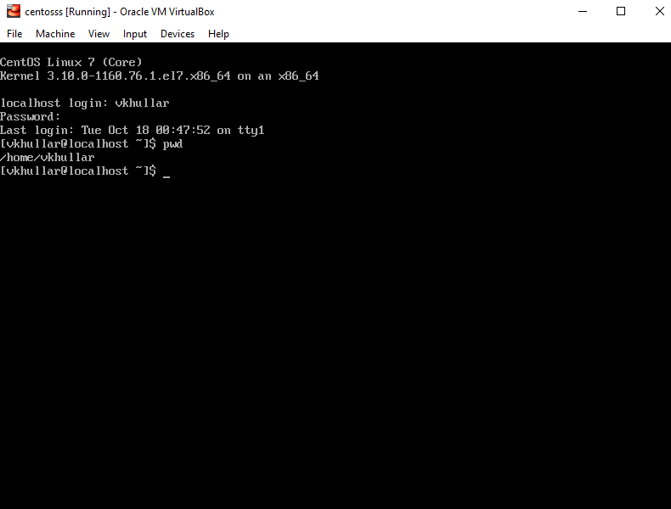

When we enter pwd, it shows present working directory

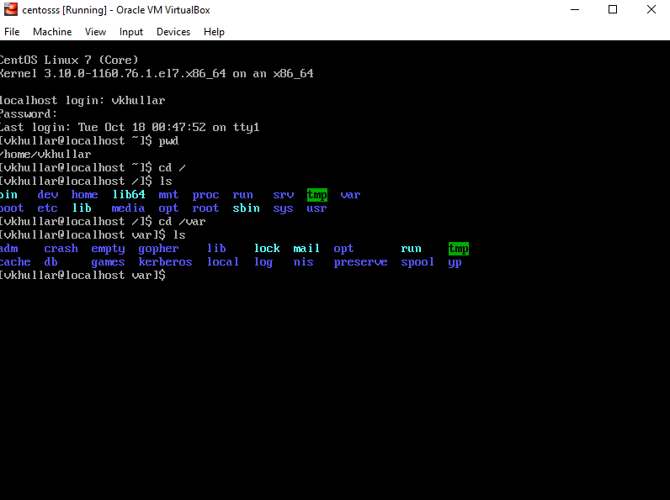

When we enter cd /var and enter ls, it lists down all directories which are defined in var directory of the root.